Lissajous Aiming In-depth

*TL;DR: Skip to the section
Testing Fine Aim Stabilization

- Lissajous patterns are created when two perpendicular harmonic motions interact, creating a variety of different shapes depending on three factors
  - amplitude: peak/trough size
  - frequency: how fast the harmonic motion squiggles
  - phase change: one harmonic has a head start
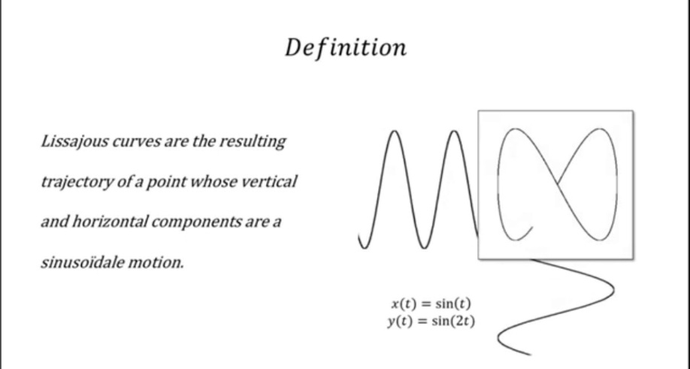
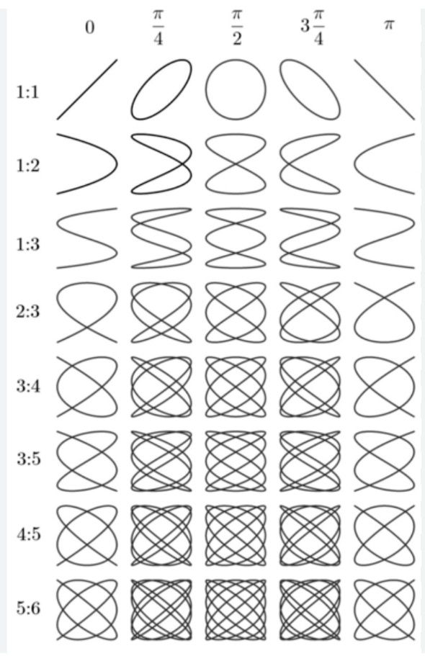

What does any of this have to do with my thumb?
- Lissajous patterns are seen in human movement.
- Lissajous overview pictures (LOP) are often used in gait analysis.
  - There are links to a couple articles at the end of the document.
- I am extrapolating this idea to thumb movement.
- The right thumb stick requires the player to use two different conical motions.

The first conical motion is for big thumb movements, using extension and flexion of the carpometacarpal joint (CMC), metacarpalphalangeal joint (MCP) and the interphalangeal joint (IP), staggered in conjunction with palmar adduction and abduction of the CMC joint.
1) CMC joint flexion/extension + MCP/IP joint flexion + extension
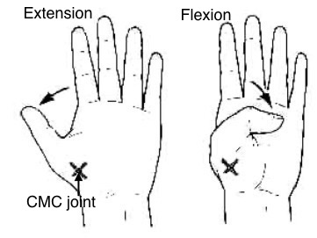

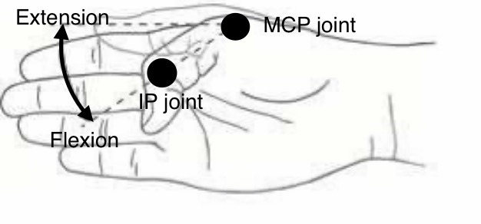

2) Palmar adduction and palmar abduction
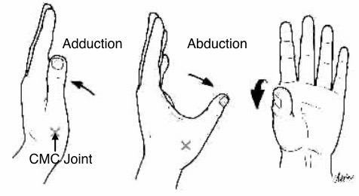
-When you do this conical motion, the circular cone base is tilted a little, so you perceive a 2d projection of a diagonal ellipse.
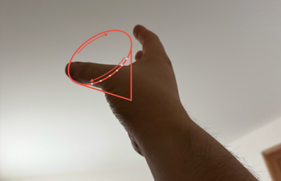

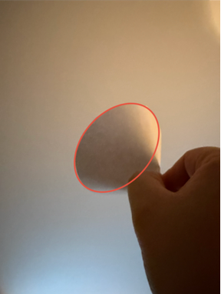
- This is different from the diagonal ellipses seen in the chart below.
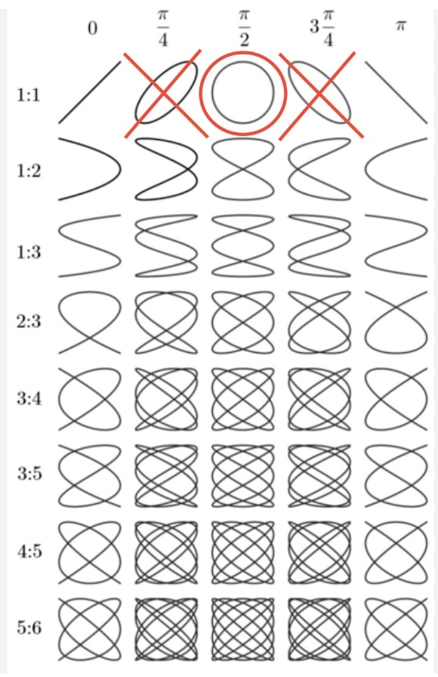
- The twirl traces a circle, which has a phase change of π/2, but the circle appears like a diagonal ellipse due to perspective change.
- However, the diagonal ellipses on the chart have phase changes of π/4 and 3π/4.
The second conical motion is for small thumb movements, which uses the same extension and flexion of the CMC joint, MCP joint, and the IP joint. However, the staggered perpendicular thumb rotation changes from palmar adduction/abduction to thumb pronation and supination.
Thumb pronation
- Thumb pad towards the palm
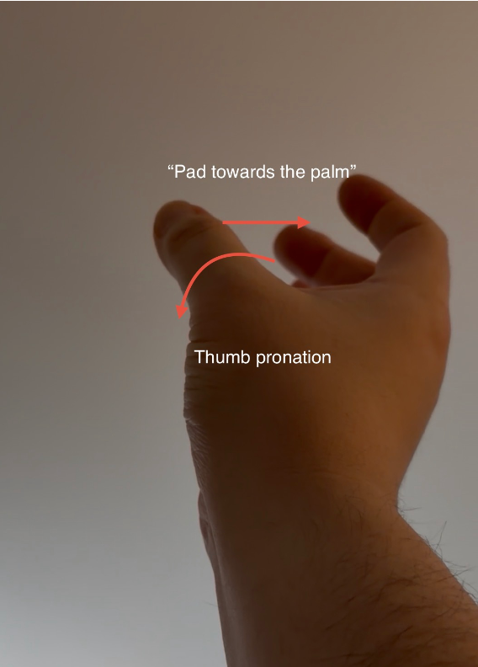

Thumb supination
- Thumb pad shifts left
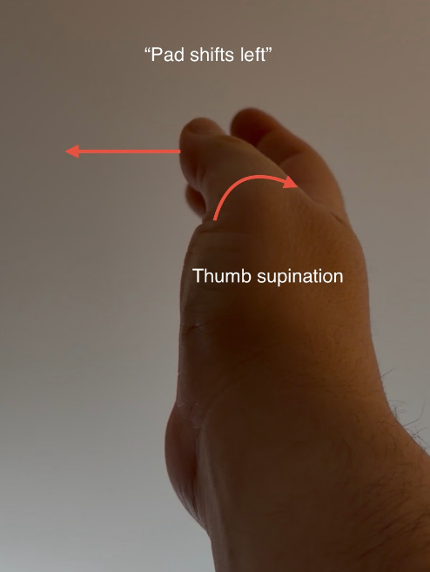

-When you do this conical motion, the circular cone base is tilted to the extent that it’s paper-thin, so you perceive a 2d projection of a squashed and bent figure 8, or what I like to call “Batman goggles”.
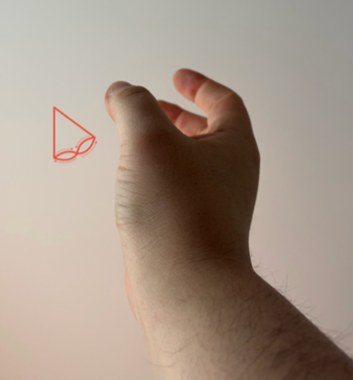

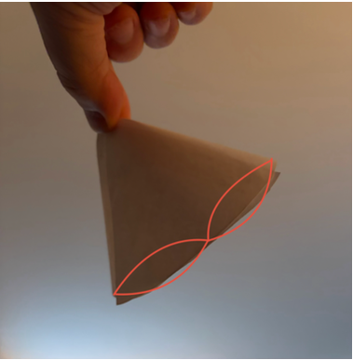
- This is different from the butterfly figure 8s seen in the chart below. Those have phase changes of π/4 and 3π/4.
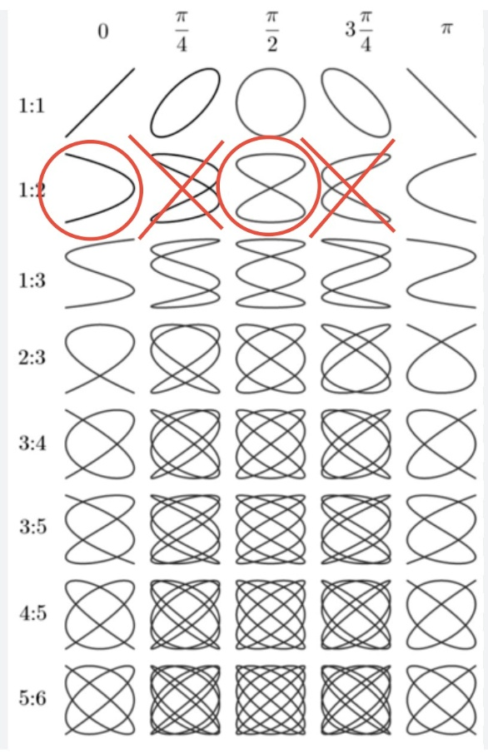
- The Batman goggles are formed by two Lissajous patterns being superimposed over each other
- One is a squashed figure 8
  - Squashed because the amplitudes differ between joint rotations
- The other is a U shape
  - This is the shape of a pendulum swing

Testing Ultra Fine Aim
Mouse aim vs Gyro ratcheting
-I mentioned in my document “Lissajous Aiming + Gyro Ratcheting” that mouse aim has gross and fine aim in both horizontal and vertical planes, but also stabilization of gross and fine aim.
-Gross aim stabilization is done by subtly compressing the forearm into the table.
-Fine aim stabilization is done by subtly compressing the mouse from the sides.
-I played with gyro ratcheting for a while, and I concluded that this aim type is similar to mouse aim, but it only can do gross aim with stabilization.
-A potential solution to close the gap further between controller aim and mouse aim could be to add fine aim with stabilization to gyro ratcheting.
-Lissajous aiming is my attempt at this solution.

Fine aim with stabilization + Gyro ratcheting
-For this to work, thumbstick inputs need to be displacement-based to retain coherence with the displacement-based nature of gyro ratcheting.
-Fine aim stabilization involves subtly compressing the thumbstick down but not overly compressing to the point the thumbstick clicks.

Explanation of the Lissajous aim code
The is a simplified explanation of the behavior mapping. When the thumbstick input magnitude is less than 0.25, it maps the thumb’s movement to the Batman goggles shape. Within the Batman goggles shape, the parametric equation squashes vertical input relative to the horizontal input. When the magnitude exceeds 0.25, it maps the thumb’s movement to a diagonal ellipse.
Demonstrating non-Lissajous fine aim stabilization
-If you have a controller to test this, open the comparison folder and you’ll see four html links containing the non-Lissajous aim codes.
-Open each code and use the right thumbstick to repeatedly trace a circle with a 1-inch diameter in the center of the screen and observe the movement shape.
-For me at least, I can’t repeat the movement with any real consistency. The movement occurs in a stop-and-go manner with large spikes, almost like you’re tracing an onomatopoeia burst you would see in comic books.

-The hybrid aim code is the best of the four, but it still spikes.
-The reason these spikes occur has to do with the Batman goggles.
-You’ll notice four “sharp turns” in the figure 8 shape.
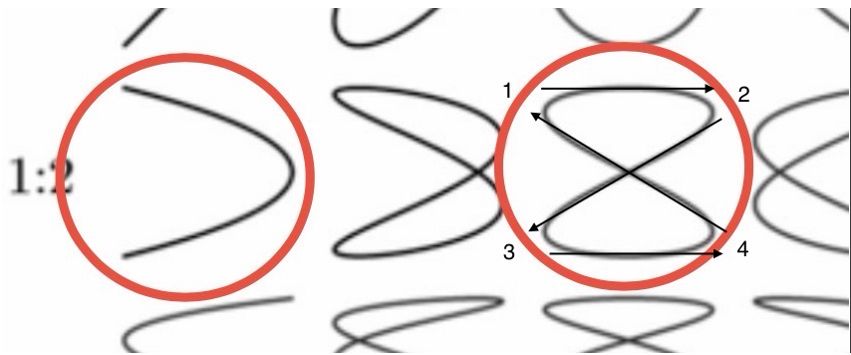
- These sharp turns manifest as spikes in the shape.

Demonstrating Lissajous fine aim stabilization
-If you have a controller to test this, open the html link for the full sized Lissajous aim code in the main folder.
-Use the right thumbstick to repeatedly trace a circle with a 1 inch diameter in the center of the screen and observe the movement shape.
-For me at least, I can trace a circle fairly accurately in a consistent repeatable manner without spikes in a stop-and-go pattern.
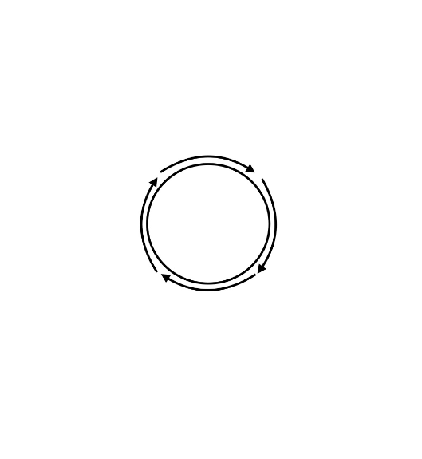
-The residual stop-and-go pattern can be attributed to the 4 sharp turns I mentioned earlier.
-This demonstration shows that Lissajous aiming can theoretically improve fine aim stabilization for displacement-based thumbstick aim.
-I also have different size variations for the Lissajous aim code you can try. Realistically, the 1/8 size would be more appropriate for weapons held with two hands. Full size or less would be for other functions, like manual reloads, weapon adjustments, selecting utility on your person, and independent aim for duel wieldable weapons, grenades, and melee attacks. You can think of it like changing your sensitivity based on context. I go into more detail about this in my other document “Innovating Marathon with Gyro Controls”.
Demonstrating mouse fine aim stabilization
-To test this, I want you to increase your DPI to an insanely high number, let’s say 5000.
-Raise the DPI high enough so that when you move the cursor in a diagonal ellipse with just finger motions, the ellipse should encompass the entire screen.
Now, try to repeatedly trace a circle with a 1-inch diameter in the center of the screen and observe the movement shape.
-For me at least, I can trace a polygon shape in a consistent repeatable manner with a stop-and-go pattern.
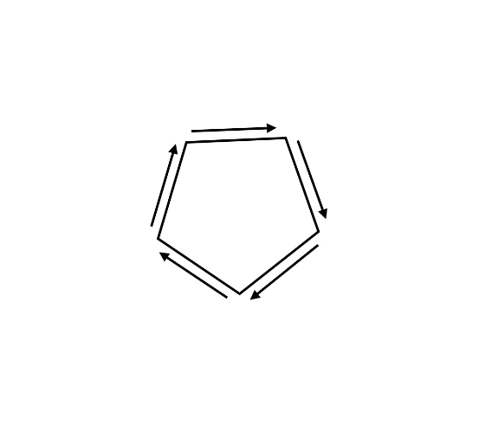
-My basic understanding as to why this happens is because mouse inputs are quantized.
-Although the movement shapes differ, there are two noticeable similarities between fine aim stabilization for mouse aim and Lissajous aim.
-Both have a stop-and-go pattern, and the movement shapes are consistently repeatable.
-Because of these similarities, I am very curious to see how Lissajous aim + gyro ratcheting compares to mouse aim.

Conclusion
I want to be clear that I do not have a background in coding, but I do have a medical background as a physician. I worked with AI to generate an aim code that uses Lissajous patterns as a guide for behavior mapping. If this code is implemented properly with gyro ratcheting, it could theoretically bridge the gap closer between controller aim and mouse aim. If you’re interested in my idea, please shoot me an email so we can collaborate. Thank you.

Eric Wong
15wonge@gmail.com
Gait research links
https://www.researchgate.net/profile/Masahiko-Mukaino/publication/305340291_Feasibility_of_a_Simplified_Clinically_Oriented_Three-dimensional_Gait_Analysis_System_for_the_Gait_Evaluation_of_Stroke_Patients/links/578a8fea08ae59aa66793d8d/Feasibility-of-a-Simplified-Clinically-Oriented-Three-dimensional-Gait-Analysis-System-for-the-Gait-Evaluation-of-Stroke-Patients.pdf?origin=publication_detail&_tp=eyJjb250ZXh0Ijp7ImZpcnN0UGFnZSI6InB1YmxpY2F0aW9uIiwicGFnZSI6InB1YmxpY2F0aW9uRG93bmxvYWQiLCJwcmV2aW91c1BhZ2UiOiJwdWJsaWNhdGlvbiJ9fQ
https://www.researchgate.net/profile/Eiichi-Saitoh-2/publication/291311206_Application_of_Lissajous_overview_picture_in_treadmill_gait_analysis/links/595c28d7458515117741c89b/Application-of-Lissajous-overview-picture-in-treadmill-gait-analysis.pdf?origin=publication_detail&_tp=eyJjb250ZXh0Ijp7ImZpcnN0UGFnZSI6InB1YmxpY2F0aW9uIiwicGFnZSI6InB1YmxpY2F0aW9uRG93bmxvYWQiLCJwcmV2aW91c1BhZ2UiOiJwdWJsaWNhdGlvbiJ9fQ

